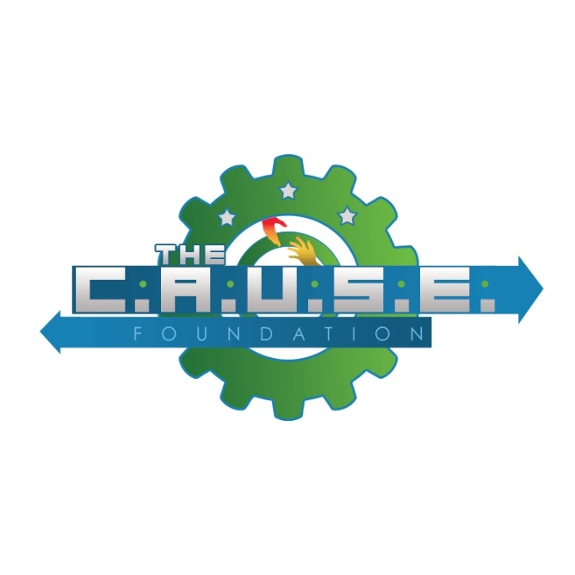
The CAUSE Foundation’s
2018 Scholarship and Awards Banquet

Our Vision:
One day a community without the ravages of poverty.

Our Mission:
The CAUSE Foundation is dedicated to enhancing the dignity and quality of life of individuals, families, and communities by eliminating barriers to opportunity and helping them to reach their full potential as productive, caring, responsible citizens through education, advocacy, and the promotion of civic awareness.

About Us:
The CAUSE Foundation is classified by the Internal Revenue Service as a 501(c) (3) non-profit organization that serves the Greater Houston area. This organization works on issues of common concern to all; sometimes joining with other organizations with mutually common objectives. The members of The CAUSE Foundation represent geographic diversity and a wide range of activities.

Our Programs and Services:
The CAUSE Foundation accomplishes its mission in a number of ways. Some of them are:
- Education Scholarships
- Community Literacy Programs
- Mentoring Programs
- Joint Community Action Programs

SPONSORS WILL RECEIVE THE FOLLOWING BENEFITS:

PLATINUM $10,000.00
- Opportunity to speak at the banquet
- Ten tickets to attend the banquet
- Special recognition, organization banner, at the banquet
- Advertising in the awards dinner program
- Acknowledgement on event website

GOLD $5,000.00
- Five tickets to attend the banquet
- Special recognition at the banquet
- Advertising in the awards dinner program
- Acknowledgement on the event website

SILVER $2,500.00
- Two tickets to attend the banquet
- Advertising in the awards dinner program
- Special recognition at the banquet
- Acknowledgement on the event website

IN-KIND SPONSOR You Define
- Advertising in the awards dinner program
- Acknowledgement on the event website
- Recognition at the banquet

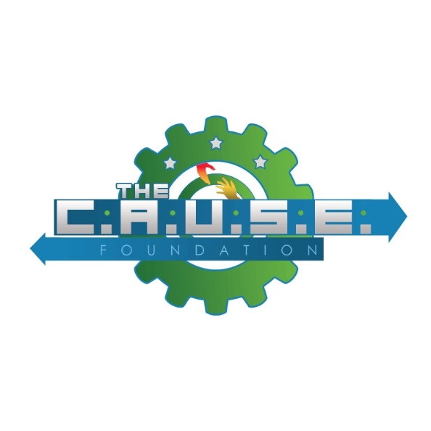
Sponsorship Reservation

The CAUSE Foundation’s
2018 Scholarship and Awards Banquet

We would like to support The CAUSE Foundation by sponsoring the 2018 Scholarship and Awards Banquet.

Organization: _____________________________________________________

Contact: _________________________________________________________

Address: _________________________________________________________

Telephone: _____________________E-mail: ____________________________

Sponsorship Level: Platinum Gold Silver In-Kind

PLEASE CONFIRM YOUR PARTICIPATION BY RETURNING THIS FORM WITH YOU SPONSORSHIP FEE BEFORE March 15, 2018:

The CAUSE Foundation
P.O. Box 1370
Fresno, TX 77545
Website: www.thecausefoundationhouston.org

Or call the Event Chairman Mr. Kurt Holloway @ 832-457-7942 and he will arrange to pick up your contribution.

THANK YOU FOR YOUR CONTRIBUTION!!!

